**Project2 report**

Jian Qiao

I compile and test my program on Mac OS X v10.9 and Ubuntu 13.04

**1. Architectural Document.**

**a) A list of WHAT new functions I added.**

**1.Function in base.c and Queue.c**

**In Queue.c**

DiskQueue *InitDiskQueue();

**This function used to initialize diskqueue.**

DISK InitDisk(PCB pnode,int token);

**This function used to pack a PCB to a Disk node so that it can be pushed into diskqueue.**

DISK EnQueueDisk(DiskQueue *queue,DISK pnode);

**This function used to push a packed PCB node to diskqueue**

DISK EnQueueDiskHead(DiskQueue *queue,DISK pnode);

**This function used to pop a packed PCB node from diskqueue**

**In base.c**

void initFrame();

**used to initialize Frame when os start operate.**

void shadow_page_table_Init();

u**sed to initialize shadow_page_table when os start operate.**

void DISKreadOrWrite(long diskID, long sectorID, char* buffer, int action);

**this function used to read data from disk to buffer if action=0 or write data in buffer to disk if action=1.**

void transfer(INT32 ID);

**this function used to find PCBs that disk is no longer in use, and return them to readyqueue.**

void FIFO(long status);

**this function implement FIFO page replacement algorithm.**

void sec_chance(long status);

**this function implement second chance page replacement algorithm.**

void mapping();

**this function used to set up a shadow page table.**

void findVictim();

**this function used in second chance page replacement algorithm to find the victim page.**

**b) High Level Design**

**There are two new system call added to my program** SYSNUM_DISK_READ and SYSNUM_DISK_WRITE.

**This part include workflow diagram of two-addition system call, fault_handler and interrupt_handler.**

1.SYSNUM_DISK_READ

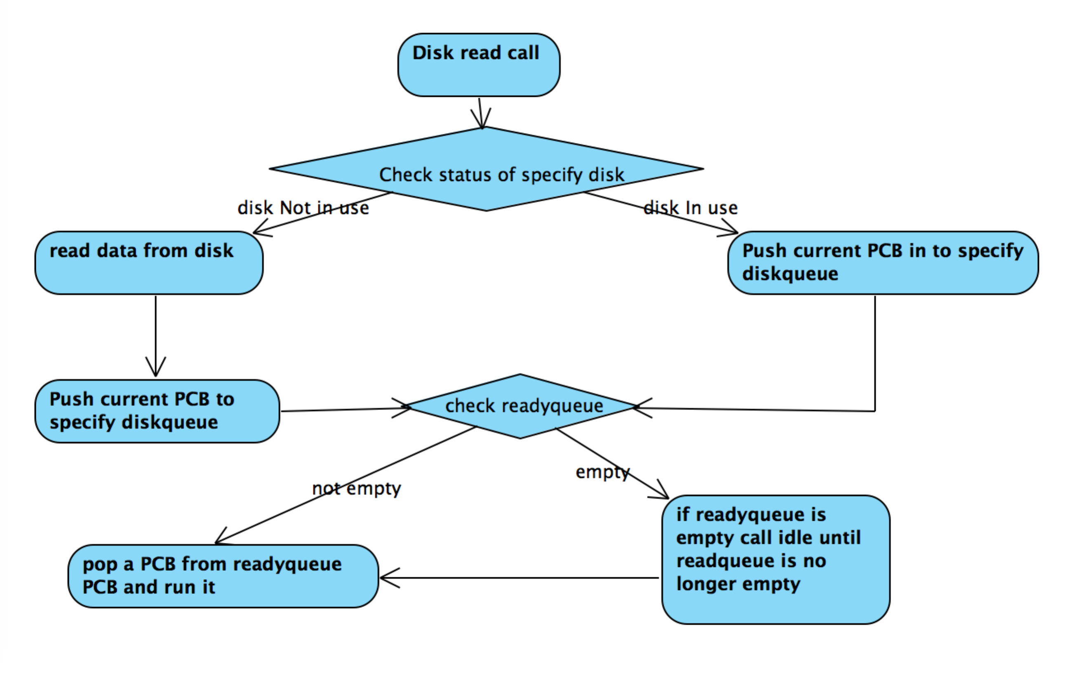

2.SYSNUM_DISK_WRITE

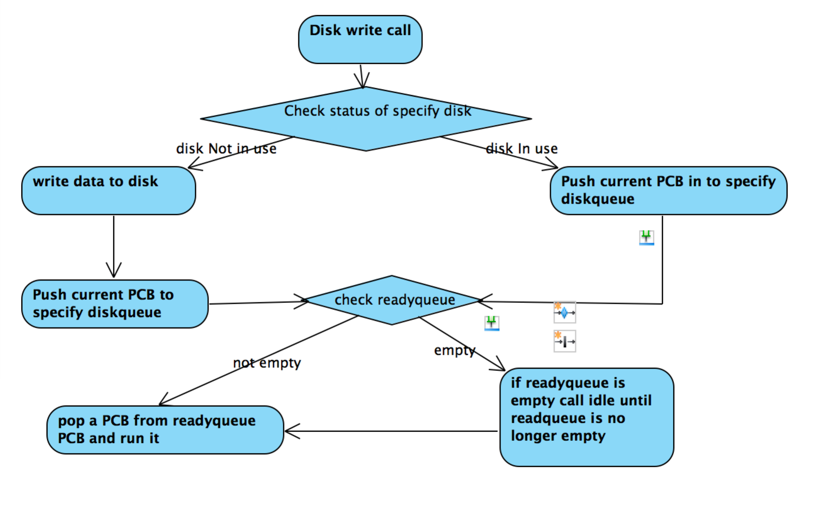

3. Interrupt handler routine

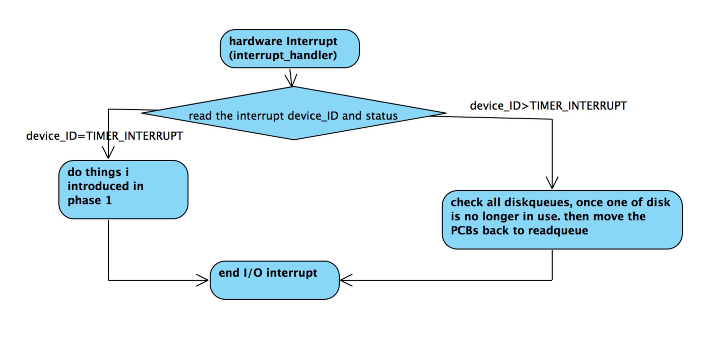

4. fault handler routine

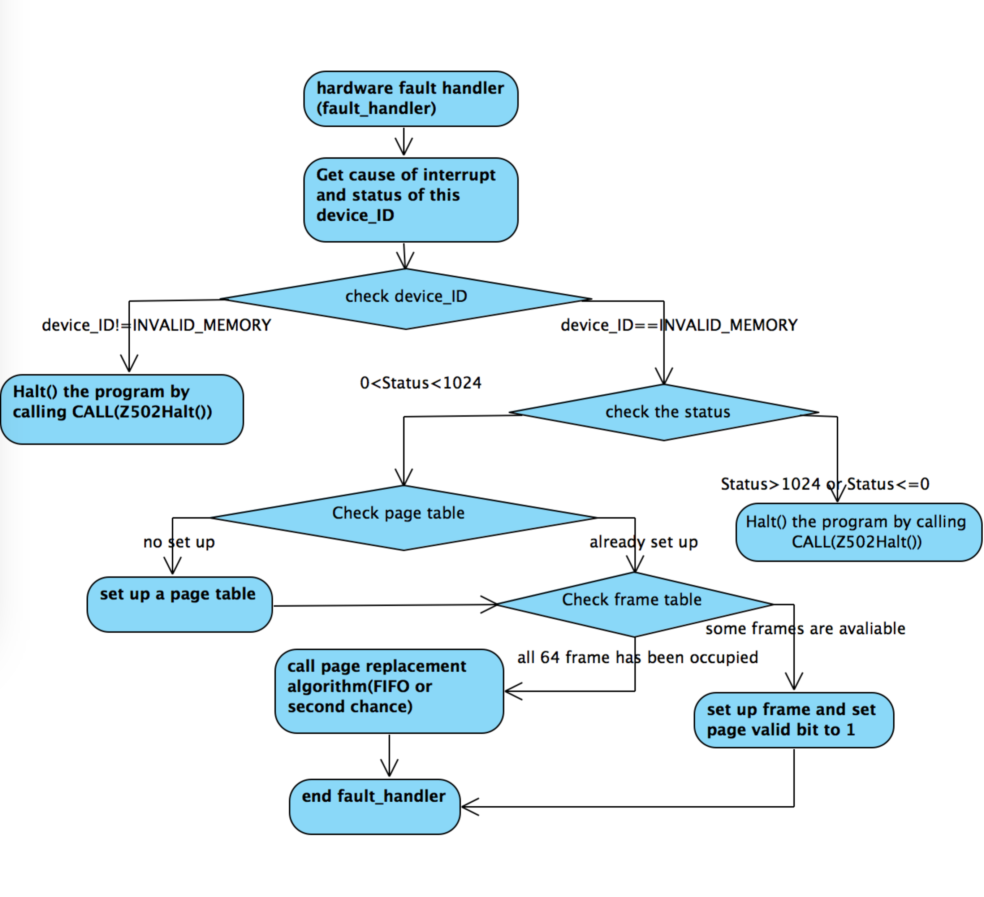

**c) Justification of High Level Design.**

Here, I am going to introduce designs that are not clear and cannot demonstrate how it works in high-level design but it is crucial to run test successfully on my porgram

**Structure**

**DiskQueue**

The structure of diskqueue is like readyqueue and timerqueue, but each disk has its own diskqueue. Therefore there are several diskqueues instead of one.

**Frame Tables**

The frame table indicates what pages are being shared among several processes; the frame table totally has 64 frames, each frame stores information of a page that in physical memory.

**Shadow page tables**

The shadow page table structures are used to describe how to find a virtual page of memory when it's not in physical memory. The shadow page table would hold disk information, for instance, indicating where to find the virtual contents should they need to be paged in.

**Logic of page replace**

Page replacement algorithm

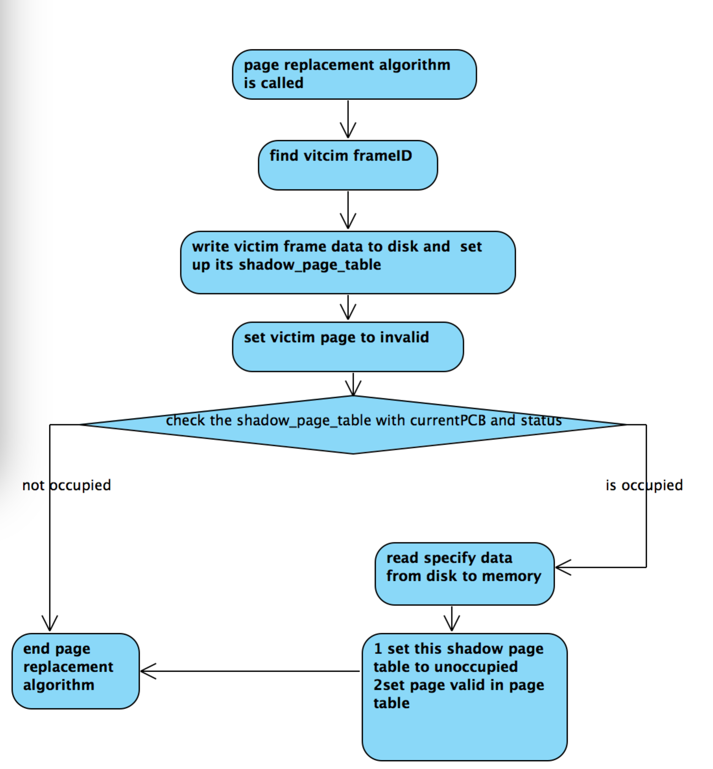

The page replacement algorithm only called when all of 64 frames have been occupied.

When the algorithm is called, it will use the rule of the algorithm to find the victim frame first. Once the victim frame has been found, we need to store the old page in to the disk. System will set up a **shadow page** with diskID=processID+1 sectorID=pageID. This is where the old page information is stored in the disk.

**e)What is UNIQUE about your project**

In my project I implement two page replacement algorithm, FIFO and second chance and compare these two page replacement algorithms in test2f.

The different between these two algorithms is that

Second chance is modify of FIFO. The advantage of second chance is that it avoid to throwing out heavily used page. But the disadvantage is that if there is no heavily used page, the performance of second chance is as same as FIFO.

What I expect is that the second chance page replacement algorithm will cause much less Faults than FIFO page replacement algorithm. But the fact is that there is no big change. Comparing to FIFO algorithm, the second chance only reduced 50-100 faults on average.

The following screenshots is the comparison of these two algorithms in test2f

FIFO

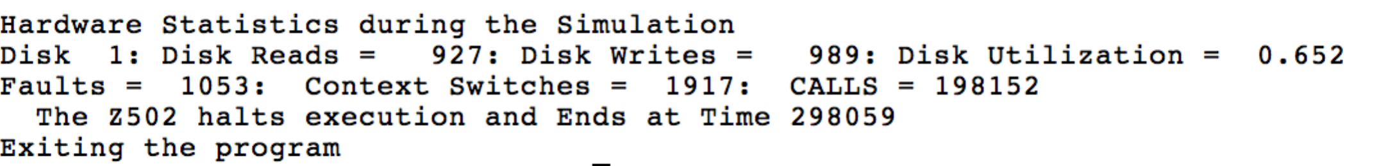

Second chance

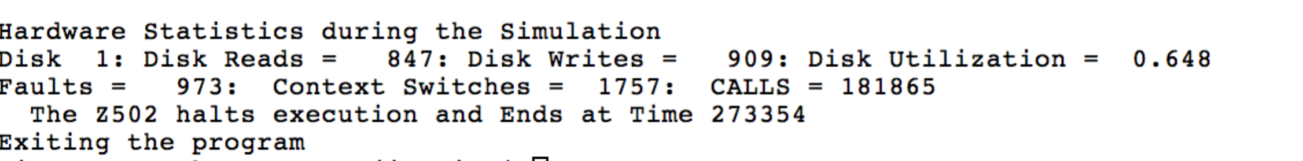

**f) What anomalies and bugs did you find?**

**anomalies**

For test2d if I run it on OSx, there is a error will occur most of the times. However I run it on Ubuntu, it works find. I have no clue how to solve it.

1. **Source Code**

base.c

Queue.h

Queue.c

1. **Test Format**

There are two variables modelctrl and printerClt I used in my program to control the output. If you set modelctrl as 0, the memory_printer will print for every page fault. If you set it as 10, every ten-page fault, the memory_printer only print once. For test2f, I set modelctrl=100. For test2e, modelctrl=10.

printerClt=0, schedule_printer will not print, Vice versa

1. **Test Results**

Test2a

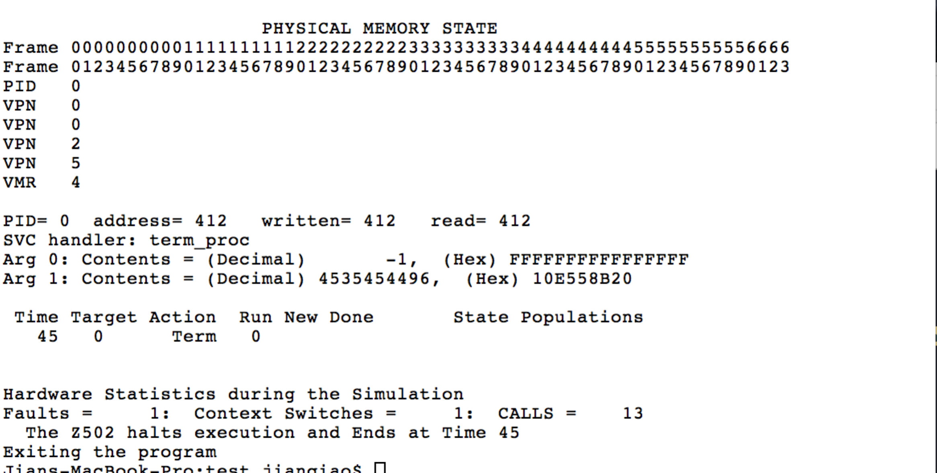

test2b

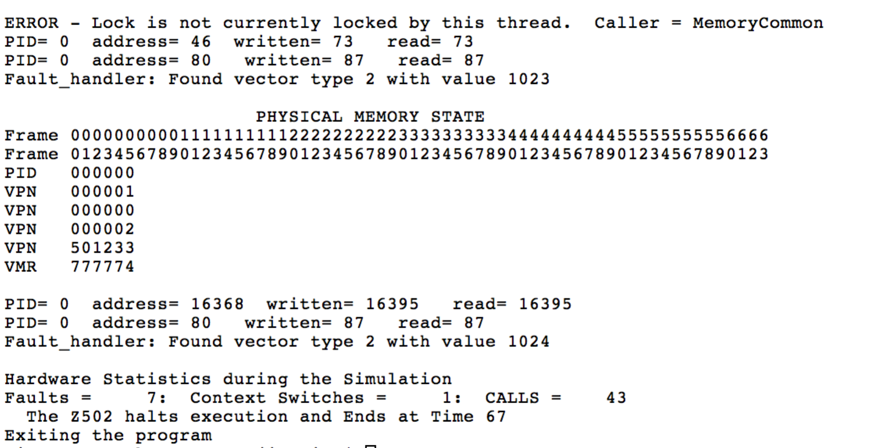

test2c

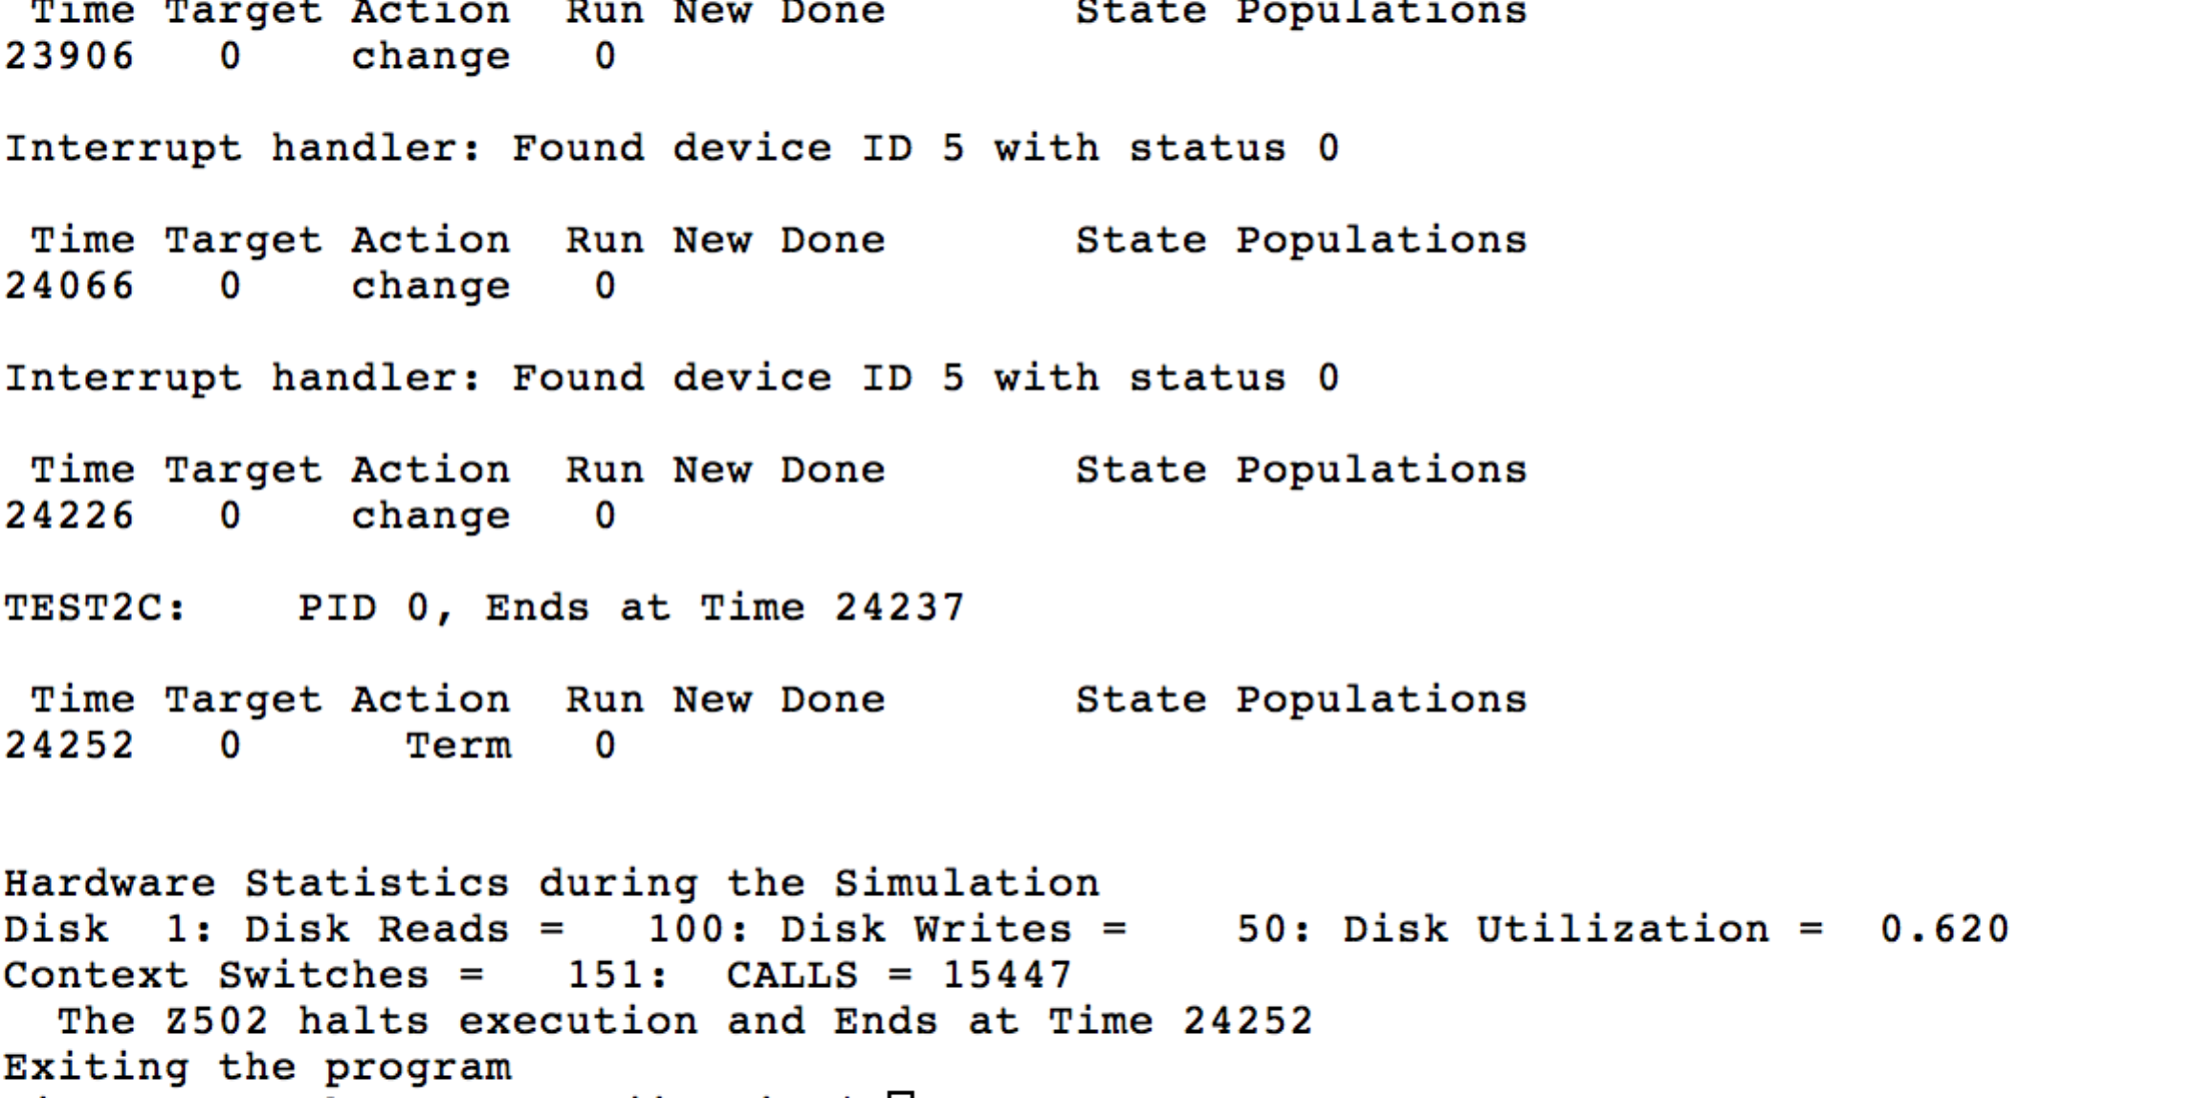

test2d

I keep schedule_printer in 2d. If I did not, there is error will occur. I have not found a way to solve it.

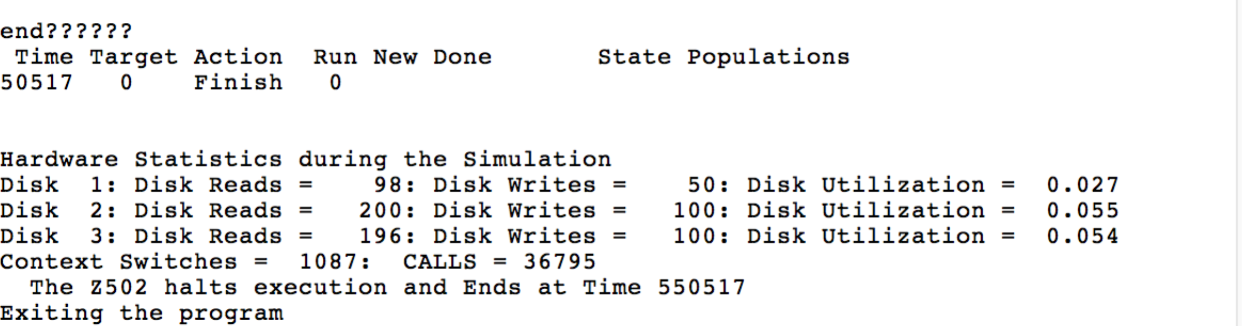

test2e

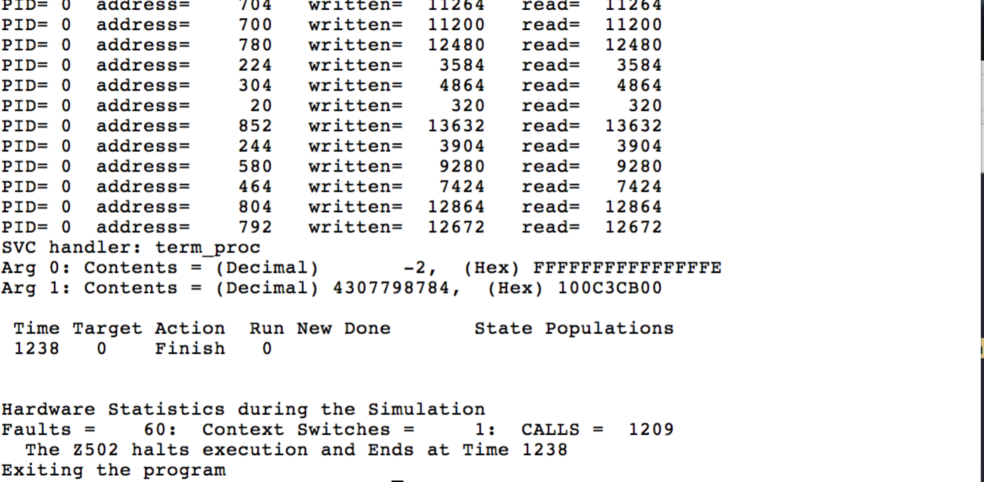

test2f

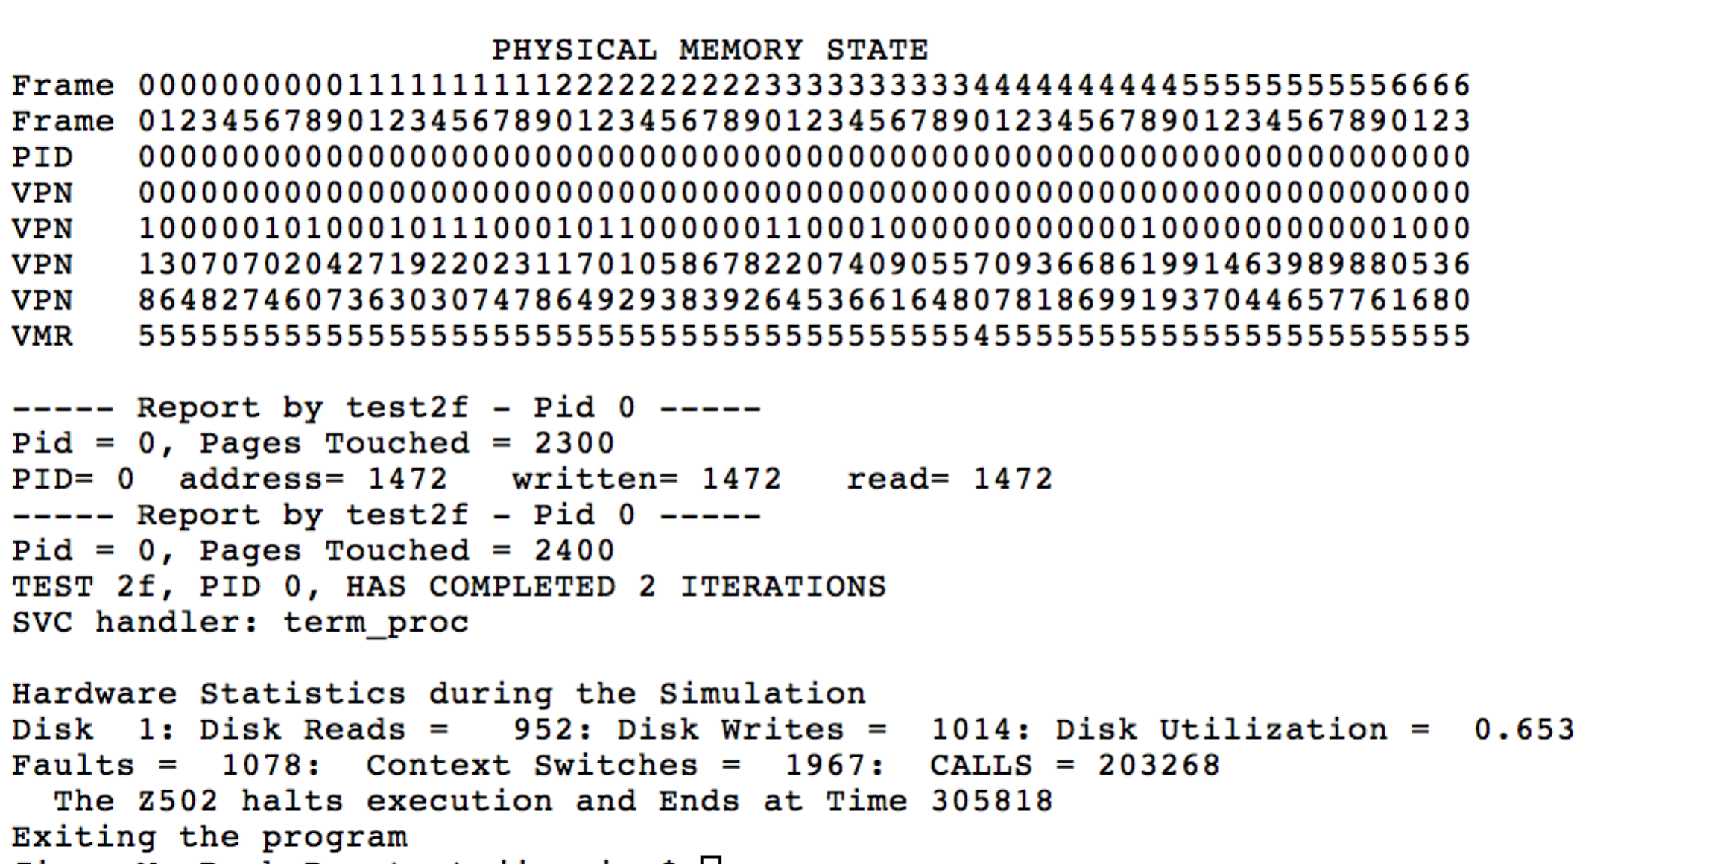

test2g

sorry I failed

test2h

I have no time to touch it.